

Itgalpura, Rajanukunte, Bengaluru - 560064

**School of Engineering**

A Project Report on

**“SOLAR PANEL”**

Submitted in partial fulfillment of the requirement for the course

Innovative Project - Arduino using embedded C (**CSE 1002**)

Submitted by

Group: IPC 114

|  |  |
| --- | --- |
| Student Name | Roll No |
| Mohan C V | 20211CCS0133 |
| Thanya Patel R | 20211CSG0043 |
| A Ajay Kumar | 20211ECE0140 |
| Gowtham R Gowda | 20211CSD0164 |
| Joel G Daniel | 20211CSE0541 |
| Yogeshwar L | 20211CSE540 |

Under the supervision of

**Guide name: Mr. Prasad P S Designation: Assistant professor Department: Department of CSE** 2021-22

Abstract:

# Solar energy is a vast, abundant, cost-free source of energy**.** Due to the

aforementioned quantities, the world is today researching and exploring the most feasibly optimized way of harnessing this energy and solar tracking system is a result of this quest. this paper begins with a brief introduction to the solar PV cells and the materials used in their construction. It also discusses the types of solar PV systems and types of solar tracking systems. It mainly focuses on the design and performance analysis of the various dual axis tracking solar systems proposed in recent years.

The idea of conversing solar energy into electrical energy using photovoltaic panels holds its place in the front row compared to other renewable sources. Solar trackers move the payload towards the sun throughout the day. The results in this review confirm that azimuth and altitude dual axis tracking system is more efficient compared to other tracking systems. However, in cost and flexibility point of view single axis tracking system is more feasible than dual axis tracking system.

Hardware, Software and tools used:

* **Arduino uno:**

A solar cell panel, solar electric panel, photo-voltaic (PV) module or solar panel is an assembly of photo-voltaic cells mounted in a framework for installation. Solar panels use sunlight as a source of energy to generate direct current electricity. A collection of PV modules is called a PV panel, and a system of PV panels is called an array. Arrays of a photovoltaic system supply solar electricity to electrical equipment.

* **Light dependent resistor LDR(Photoresistors):**

Light dependent resistors, LDRs, or photoresistors are electronic components that are used to detect light & change the operation of a circuit dependent upon the light levels. A photoresistor or light dependent resistor is an electronic component that is sensitive to light. When light falls upon it, then the resistance changes. Values of the resistance of the LDR may change over many orders of magnitude the value of the resistance falling as the level of light increases.

* **Servomotor:**

A servomotor (or servo motor) is a rotary actuator or linear actuator that allows for precise control of angular or linear position, velocity and acceleration. It consists of a suitable motor coupled to a sensor for position feedback. It also requires a relatively sophisticated controller, often a dedicated module designed specifically for use with servomotors.

* **Resistors:**

A resistor is a passive two-terminal electrical component that implements electrical resistance as a circuit element. In electronic circuits, resistors are used to reduce current flow, adjust signal levels, to divide voltages, bias active elements, and terminate transmission lines, among other uses. High-power resistors that can dissipate many watts of electrical power as heat may be used as part of motor controls, in power distribution systems, or as test loads for generators. Fixed resistors have resistances that only change slightly with temperature, time or operating voltage. Variable resistors can be used to adjust circuit elements (such as a volume control or a lamp dimmer), or as sensing devices for heat, light, humidity, force, or chemical activity.

# Block diagram & Description

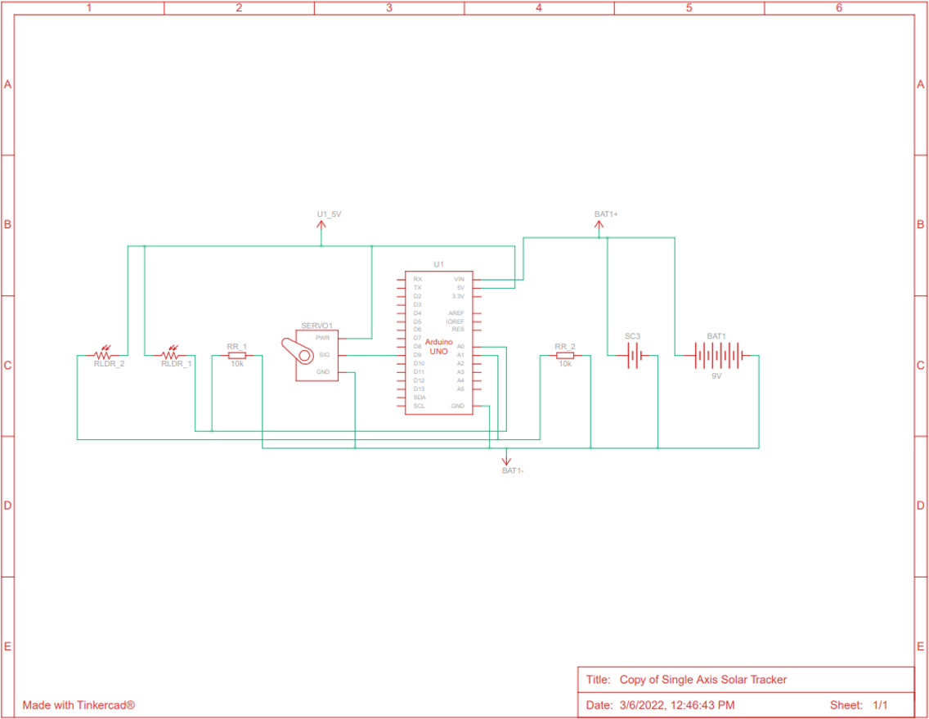

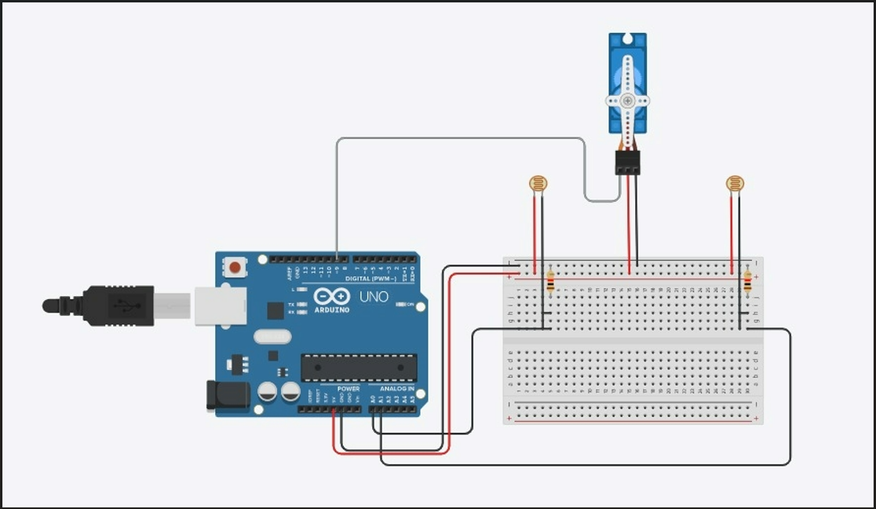

Working of Solar Tracker:

* The solar tracking system comprises of a solar panel, Arduino microcontroller and sensors.
* For this system to operate there must be emission of light through the sun.
* The LDRs serve as the sensors to detect the intensity of light entering the solar panels.
* The LDR then sends information to the Arduino microcontroller. The servo motor circuit is then constructed.
* The servo has 3 pins of which the positive side is connected to the +5v of the Arduino microcontroller.
* Negative of the servo is connected to the ground.
* The data point on the servo is connected to the analog point on the microcontroller.

Results (Model’s image):

**Project overview:**

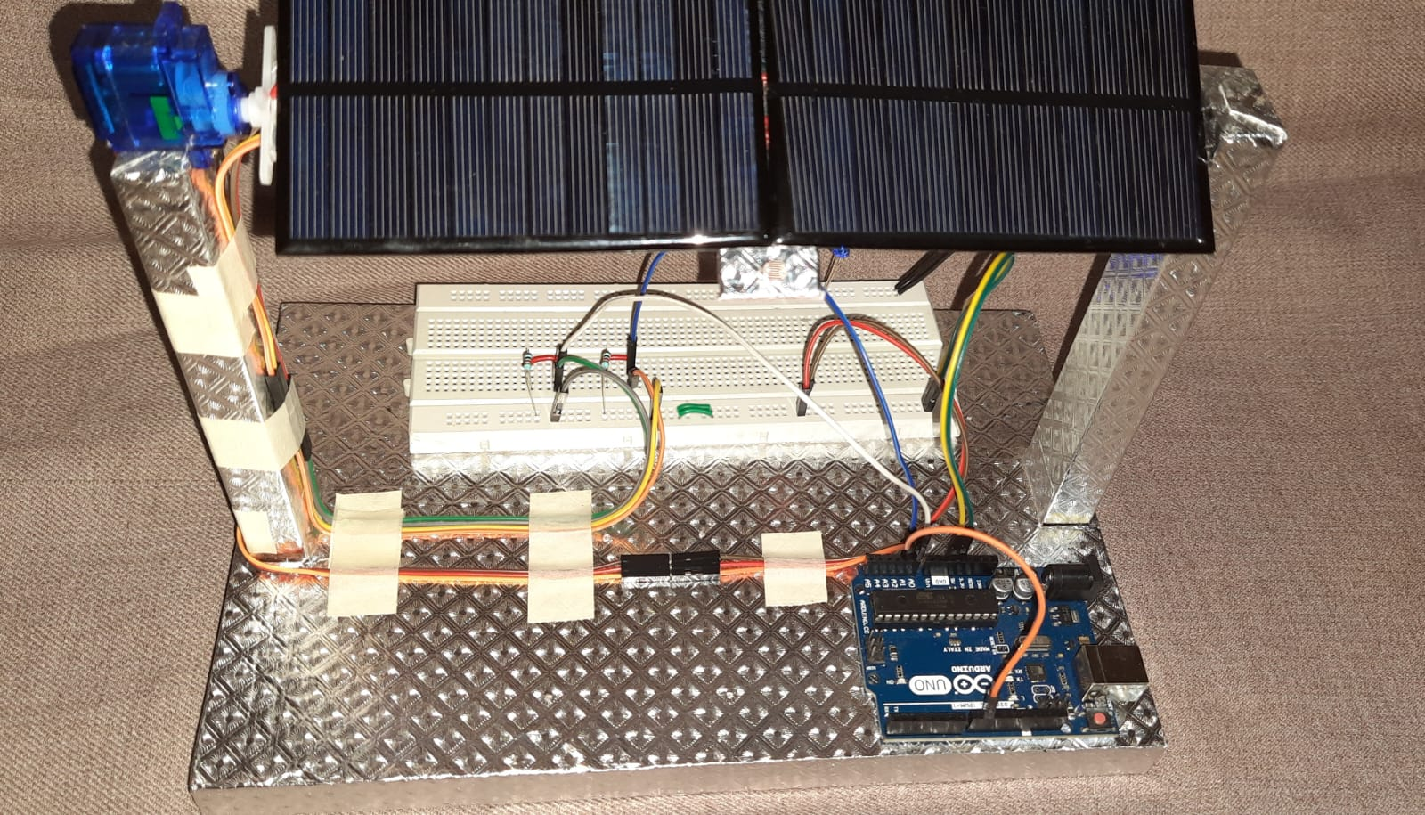

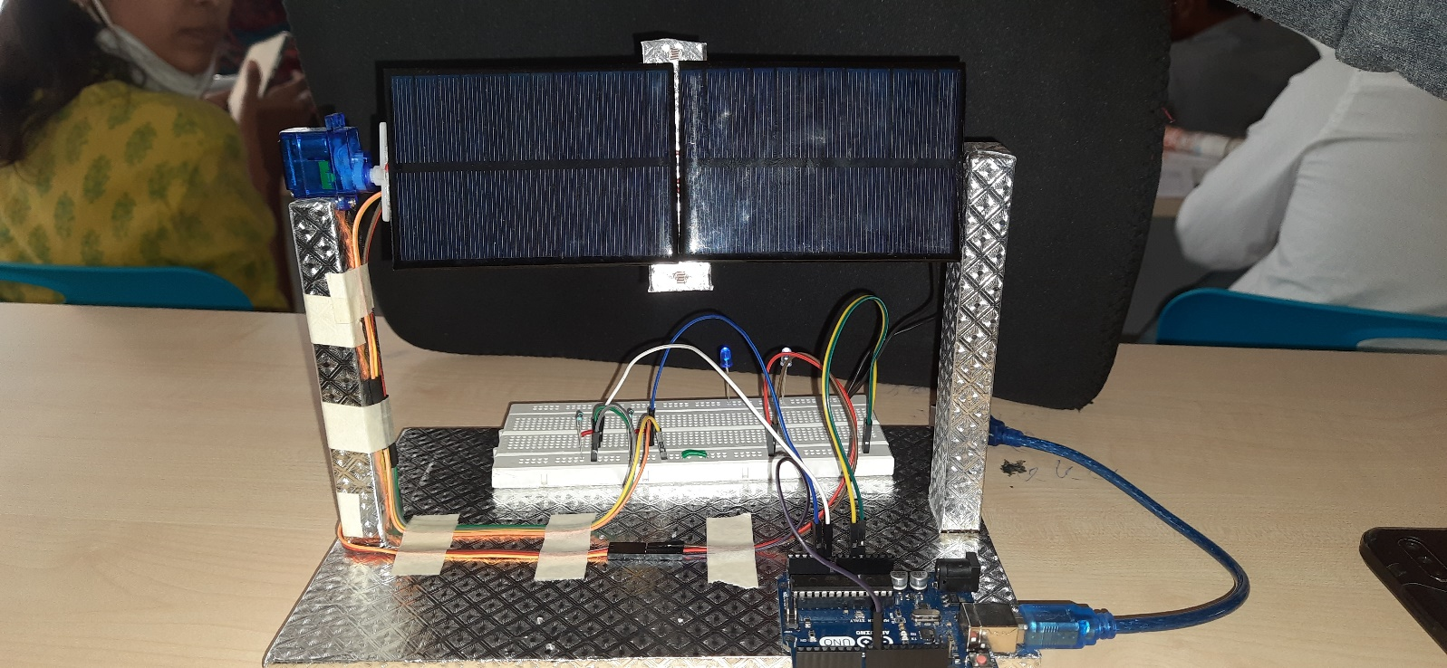

Challenges faced:

* Time constraint
* Finding suitable hardware components
* Assembling and working of hardware components
* Creating a suitable programming code for more efficient and working prototype.

Conclusion:

* The aim of the solar panel tracking system is to track the position of the sun for better efficiency of the solar panel has shown in the experimental results.
* This work can be executed on an industrial scale which be beneficial to developing countries like India and other countries across the globe.
* Our recommendation for future works is to consider the use of more sensitive and efficient sensors which consume less power and which are also cost effective.
* This would increase the efficiency while reducing cost.